1. **Design a Student House President Election 2017 form with fields such as Choose a candidate (use DropDownList), House (use RadioButtonList), Class (6th to 12th), email id, parent contact number and a submit button. Display message “Successfully Submitted” on clicking Submit button i.e. after successful validation of election form.**

**Use:**

**1. RequiredFieldValidator - for Choose Candidate, House, Class, Email Id fields.**

**2. RangeValidator – for Class field.**

**3. RegularExpressionValidator - for Email field.**

**4. CustomValidator - for contact number field.**

**5. Validation Summary to show errors in a message box**

**Code:**

**WebForm1.aspx:**

<%@ Page Language="C#" AutoEventWireup="true" CodeBehind="WebForm1.aspx.cs" Inherits="q1.WebForm1" %>

<!DOCTYPE html>

<html xmlns="http://www.w3.org/1999/xhtml">

<head runat="server">

<title>Election 2017</title>

<style>

body h2{

font-weight: bolder;

}

</style>

</head>

<body style="height: 100%">

<form id="form1" runat="server">

<div style="font-family: 'Century Gothic'; background-color: #99CCFF; width:100%; text-align: center; overflow: scroll; height: 100%; font-size: medium; font-weight: bold;">

<br />

<br />

<br />

<h2>STUDENT HOUSE PRESIDENT ELECTION</h2><br />

Choose a candidate:&nbsp;<asp:DropDownList ID="DropDownList1" runat="server" Height="28px" Width="128px" style="vertical-align: middle; margin-left: 2px">

<asp:ListItem>A</asp:ListItem>

<asp:ListItem>B</asp:ListItem>

<asp:ListItem>C</asp:ListItem>

</asp:DropDownList>

&nbsp;

<asp:RequiredFieldValidator ID="RequiredFieldValidator1" runat="server" ErrorMessage="Please choose a candidate" Display="None" ControlToValidate="DropDownList1"></asp:RequiredFieldValidator>

<br />

<br />

House:&nbsp;

<asp:RadioButtonList ID="RadioButtonList1" runat="server" style="display: inline; vertical-align: top; text-align:left; margin-left: 55px">

<asp:ListItem>Emerald</asp:ListItem>

<asp:ListItem>Ruby</asp:ListItem>

<asp:ListItem>Sapphire</asp:ListItem>

<asp:ListItem>Topaz</asp:ListItem>

</asp:RadioButtonList>

<asp:RequiredFieldValidator ID="RequiredFieldValidator2" runat="server" ErrorMessage="Please choose a house" Display="None" ControlToValidate="RadioButtonList1"></asp:RequiredFieldValidator>

<br />

<br />

<br />

&nbsp;&nbsp;&nbsp;&nbsp;&nbsp; Class:&nbsp;

<asp:TextBox ID="TextBox1" runat="server" style="vertical-align: middle; margin-left: 105px" Width="138px"></asp:TextBox>

<asp:RequiredFieldValidator ID="RequiredFieldValidator4" runat="server" ErrorMessage="Please enter a class" Display="None" ControlToValidate="TextBox1"></asp:RequiredFieldValidator>

<asp:RangeValidator ID="RangeValidator1" runat="server" ErrorMessage="You must be studying in Class 6-12" Display="None" ControlToValidate="TextBox1" MaximumValue="12" MinimumValue="6" Type="Integer"></asp:RangeValidator>

<br />

<br />

Email id:

<asp:TextBox ID="TextBox2" runat="server" style="vertical-align: middle; margin-left: 95px"></asp:TextBox>

<asp:RequiredFieldValidator ID="RequiredFieldValidator3" runat="server" ErrorMessage="Please enter your email-id" Display="None" ControlToValidate="TextBox2"></asp:RequiredFieldValidator>

<asp:RegularExpressionValidator ID="RegularExpressionValidator1" runat="server" ErrorMessage="Enter correct email id" Display="None" ValidationExpression="\S+@\S+\.\S+" ControlToValidate="TextBox2"></asp:RegularExpressionValidator>

<br />

<br />

Parent Phone Number:

<asp:TextBox ID="TextBox3" runat="server" Width="143px" style="vertical-align: middle"></asp:TextBox>

<asp:RequiredFieldValidator ID="RequiredFieldValidator5" runat="server" ErrorMessage="Please enter a 10 digit phone number" Display="None" ControlToValidate="TextBox3"></asp:RequiredFieldValidator>

<asp:CustomValidator ID="CustomValidator1" runat="server" ErrorMessage="Please enter a 10 digit phone number" ValidateEmptyText="false" OnServerValidate="val_Phone" ControlToValidate="TextBox3" Display="None"/>

<br />

<br />

<asp:Button ID="Button1" runat="server" Text="Submit" BackColor="#B9DCFF" ForeColor="Black" Height="31px" Width="72px" style="font-family: 'Century Gothic'; font-weight: bold" OnClick="Button1_Click" />

<br />

<br />

<asp:Label ID="Label1" runat="server" EnableViewState="False"></asp:Label>

<asp:ValidationSummary ID="errors" runat="server" ShowMessageBox="true" ShowSummary="true" />

</div>

</form>

</body>

</html>

**WebForm1.aspx.cs:**

using System;

using System.Collections.Generic;

using System.Linq;

using System.Web;

using System.Web.UI;

using System.Web.UI.WebControls;

namespace q1

{

public partial class WebForm1 : System.Web.UI.Page

{

protected void Page_Load(object sender, EventArgs e)

{

DropDownList1.SelectedIndex = -1;

}

protected void Button1_Click(object sender, EventArgs e)

{

Page.Validate();

if (Page.IsValid)

{

Label1.Text = "Successfully Submitted";

}

}

protected void val_Phone(object source, ServerValidateEventArgs e)

{

if (String.IsNullOrWhiteSpace(TextBox3.Text))

e.IsValid = false;

else

{

string num = TextBox3.Text;

double t;

if (num.Length == 10 && double.TryParse(num, out t))

{

e.IsValid = true;

}

else

{

e.IsValid = false;

}

}

}

}

}

**Output:**

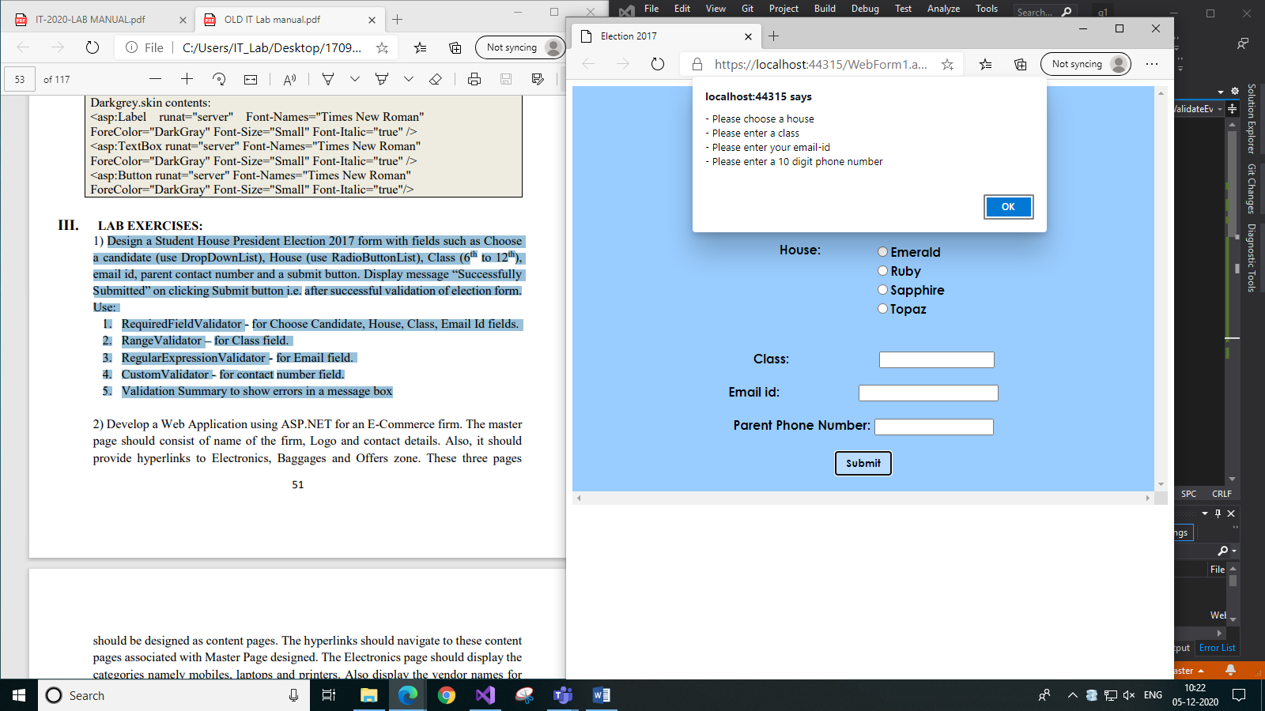

1. *When none of the fields are entered*

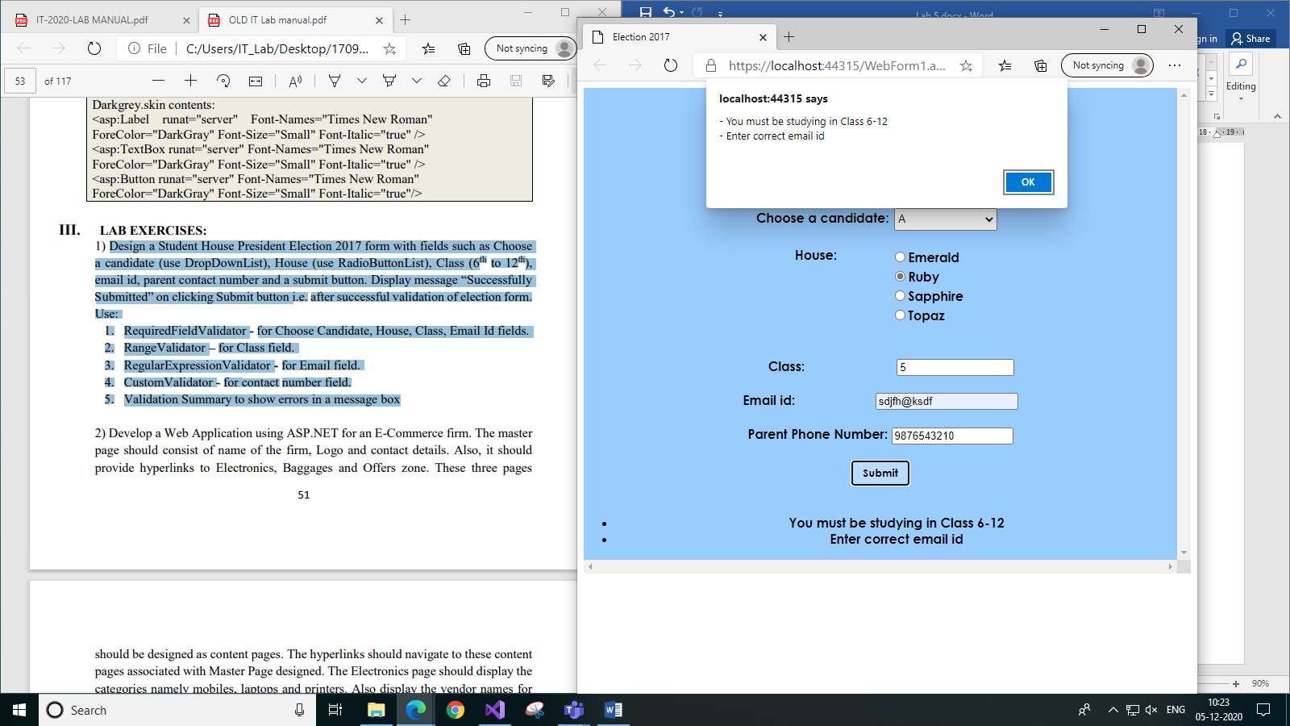

1. *When class is out of range and invalid email entered*

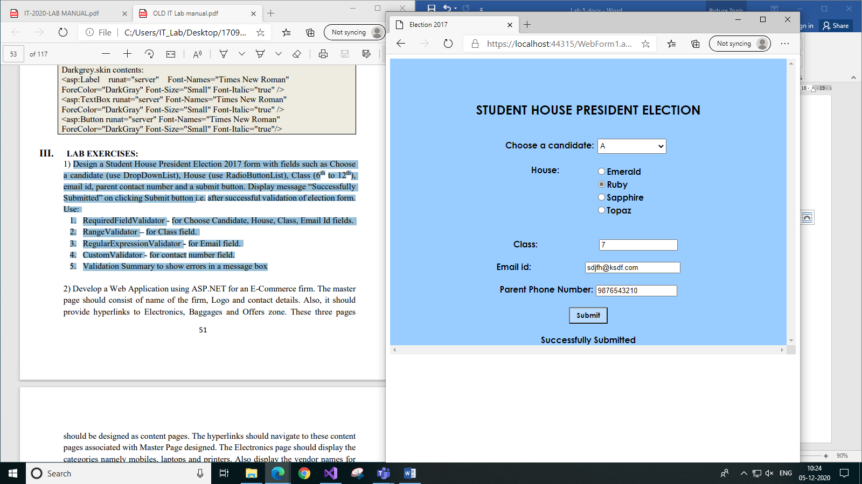

1. *When all fields are entered correctly*
2. **Develop a Web Application using ASP.NET for an E-Commerce firm. The master page should consist of name of the firm, Logo and contact details. Also, it should provide hyperlinks to Electronics, Baggages and Offers zone. These three pages 52 should be designed as content pages. The hyperlinks should navigate to these content pages associated with Master Page designed. The Electronics page should display the categories namely mobiles, laptops and printers. Also display the vendor names for all the categories in DropDownList controls. The Baggages page can have images of laptop bags, trolley bags, and backpacks. In the Offers zone page, add images to display at least two offers. All the pages must have the same background image (something that represents the firm). All the pages should be neat and well designed (the contents added must be proportional to page size) and have an attractive look.**

**Code:**

Note: Used a background colour in same theme instead of background image for the entire site.

**ecommMaster.Master:**

<%@ Master Language="C#" AutoEventWireup="true" CodeBehind="ecommMaster.master.cs" Inherits="q2.ecommMaster" %>

<!DOCTYPE html>

<html>

<head runat="server">

<title>E-Commerce Site</title>

<style>

.first{

position: absolute;

width: 300px;

top: 293px;

left: 20px;

}

.second{

position: absolute;

left: 340px;

width: 300px;

top: 293px;

}

.third{

position: absolute;

left: 660px;

width: 300px;

top: 293px;

}

</style>

</head>

<body style="background-color: lavenderblush;">

<form id="form1" runat="server">

<div style="text-align: center; font-family: Bahnschrift; color: darkslategray; background-color: lavenderblush">

<h1 style="font-family: 'BankGothic Md BT'; color: black">[Name of the Firm]</h1>

<asp:Image ID="Image1" runat="server" Height="91px" Width="96px" ImageUrl="~/Images/logo.png" /><br />

<br />

Phone: 9876543210<br />

Email: example@nameoffirm.com<br />

<br />

<asp:HyperLink ID="HyperLink1" runat="server" NavigateUrl="Electronics.aspx" ForeColor="#0066cc">Electronics</asp:HyperLink>

&nbsp;&nbsp;&nbsp;

<asp:HyperLink ID="HyperLink2" runat="server" NavigateUrl="Baggages.aspx" ForeColor="#0066cc">Baggages</asp:HyperLink>

&nbsp;&nbsp;&nbsp;

<asp:HyperLink ID="HyperLink3" runat="server" NavigateUrl="Offers.aspx" ForeColor="#0066cc">Offers</asp:HyperLink>

<br /><br /><br />

<div class="first">

<asp:ContentPlaceHolder ID="ContentPlaceHolder1" runat="server">

</asp:ContentPlaceHolder>

</div>

<div class="second">

<asp:ContentPlaceHolder ID="ContentPlaceHolder2" runat="server">

</asp:ContentPlaceHolder>

</div>

<div class="third">

<asp:ContentPlaceHolder ID="ContentPlaceHolder3" runat="server">

</asp:ContentPlaceHolder>

</div>

</div>

</form>

</body>

</html>

**Electronics.aspx:**

<%@ Page Title="Electronics" Language="C#" MasterPageFile="~/ecommMaster.Master" AutoEventWireup="true" CodeBehind="Electronics.aspx.cs" Inherits="q2.Electronics" Theme="DropDown" %>

<asp:Content ID="Content1" ContentPlaceHolderID="ContentPlaceHolder1" runat="server">

<h3>Mobiles</h3>

<asp:Image ID="Image1" runat="server" Width="100%" ImageUrl="~/Images/mobiles.jpg" Height="150px" /><br /><br />

Vendors: <asp:DropDownList ID="DropDownList1" runat="server" style="vertical-align: middle">

<asp:ListItem>Vendor1</asp:ListItem>

<asp:ListItem>Vendor2</asp:ListItem>

<asp:ListItem>Vendor3</asp:ListItem>

</asp:DropDownList>

<br /><br />

</asp:Content>

<asp:Content ID="Content2" ContentPlaceHolderID="ContentPlaceHolder2" runat="server">

<h3>Laptops</h3>

<asp:Image ID="Image2" runat="server" Width="100%" ImageUrl="~/Images/laptops.jpg" Height="150px" /><br /><br />

Vendors: <asp:DropDownList ID="DropDownList2" runat="server" style="vertical-align: middle">

<asp:ListItem>Vendor1</asp:ListItem>

<asp:ListItem>Vendor2</asp:ListItem>

<asp:ListItem>Vendor3</asp:ListItem>

</asp:DropDownList>

<br /><br />

</asp:Content>

<asp:Content ID="Content3" ContentPlaceHolderID="ContentPlaceHolder3" runat="server">

<h3>Printers</h3>

<asp:Image ID="Image3" runat="server" Width="100%" ImageUrl="~/Images/printers.png" Height="150px" /><br /><br />

Vendors: <asp:DropDownList ID="DropDownList3" runat="server" style="vertical-align: middle">

<asp:ListItem>Vendor1</asp:ListItem>

<asp:ListItem>Vendor2</asp:ListItem>

<asp:ListItem>Vendor3</asp:ListItem>

</asp:DropDownList>

<br /><br />

</asp:Content>

**Baggages.aspx:**

<%@ Page Title="Baggages" Language="C#" MasterPageFile="~/ecommMaster.Master" AutoEventWireup="true" CodeBehind="Baggages.aspx.cs" Inherits="q2.Baggages" %>

<asp:Content ID="Content1" ContentPlaceHolderID="ContentPlaceHolder1" runat="server">

<h3>Laptop Bags</h3>

<asp:Image ID="Image1" runat="server" Width="100%" ImageUrl="~/Images/laptop-bags.jpg" Height="331px" /><br /><br />

<asp:Image ID="Image2" runat="server" Width="100%" /><br /><br />

<asp:Image ID="Image3" runat="server" Width="100%" /><br /><br />

<br /><br />

</asp:Content>

<asp:Content ID="Content2" ContentPlaceHolderID="ContentPlaceHolder2" runat="server">

<h3>Trolley Bags</h3>

<asp:Image ID="Image4" runat="server" Width="100%" ImageUrl="~/Images/trolley.png" Height="331px" /><br /><br />

<asp:Image ID="Image5" runat="server" Width="100%" /><br /><br />

<asp:Image ID="Image6" runat="server" Width="100%" /><br /><br />

<br /><br />

</asp:Content>

<asp:Content ID="Content3" ContentPlaceHolderID="ContentPlaceHolder3" runat="server">

<h3>Backpacks</h3>

<asp:Image ID="Image7" runat="server" Width="100%" ImageUrl="~/Images/backpacks.png" Height="333px" /><br /><br />

<asp:Image ID="Image8" runat="server" Width="100%" /><br /><br />

<asp:Image ID="Image9" runat="server" Width="100%" /><br /><br />

<br /><br />

</asp:Content>

**Offers.aspx:**

<%@ Page Title="" Language="C#" MasterPageFile="~/ecommMaster.Master" AutoEventWireup="true" CodeBehind="Offers.aspx.cs" Inherits="q2.Offers" %>

<asp:Content ID="Content1" ContentPlaceHolderID="ContentPlaceHolder1" runat="server">

<h3>#Offer1</h3>

<asp:Image ID="Image1" runat="server" Width="100%" ImageUrl="~/Images/offer1.png" /><br /><br />

</asp:Content>

<asp:Content ID="Content2" ContentPlaceHolderID="ContentPlaceHolder2" runat="server">

<h3>#Offer2</h3>

<asp:Image ID="Image2" runat="server" Width="100%" ImageUrl="~/Images/offers2.jpg" Height="160px" /><br /><br />

</asp:Content>

<asp:Content ID="Content3" ContentPlaceHolderID="ContentPlaceHolder3" runat="server">

<h3>#Offer3</h3>

<asp:Image ID="Image3" runat="server" Width="100%" ImageUrl="~/Images/offer1.png" /><br /><br />

</asp:Content>

**Output:**

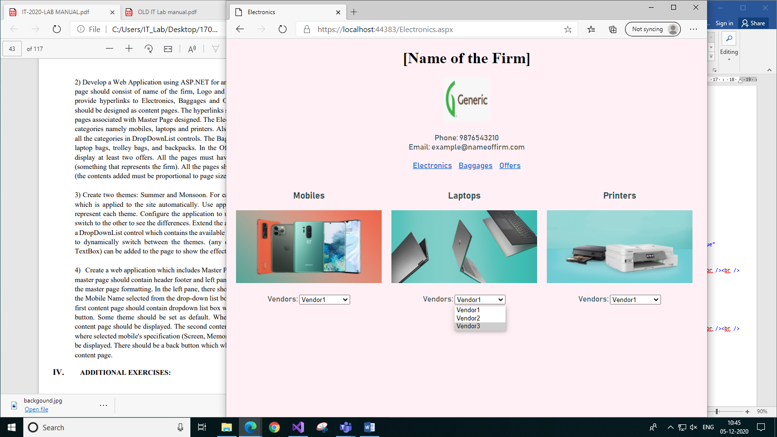

1. *Electronics Page*

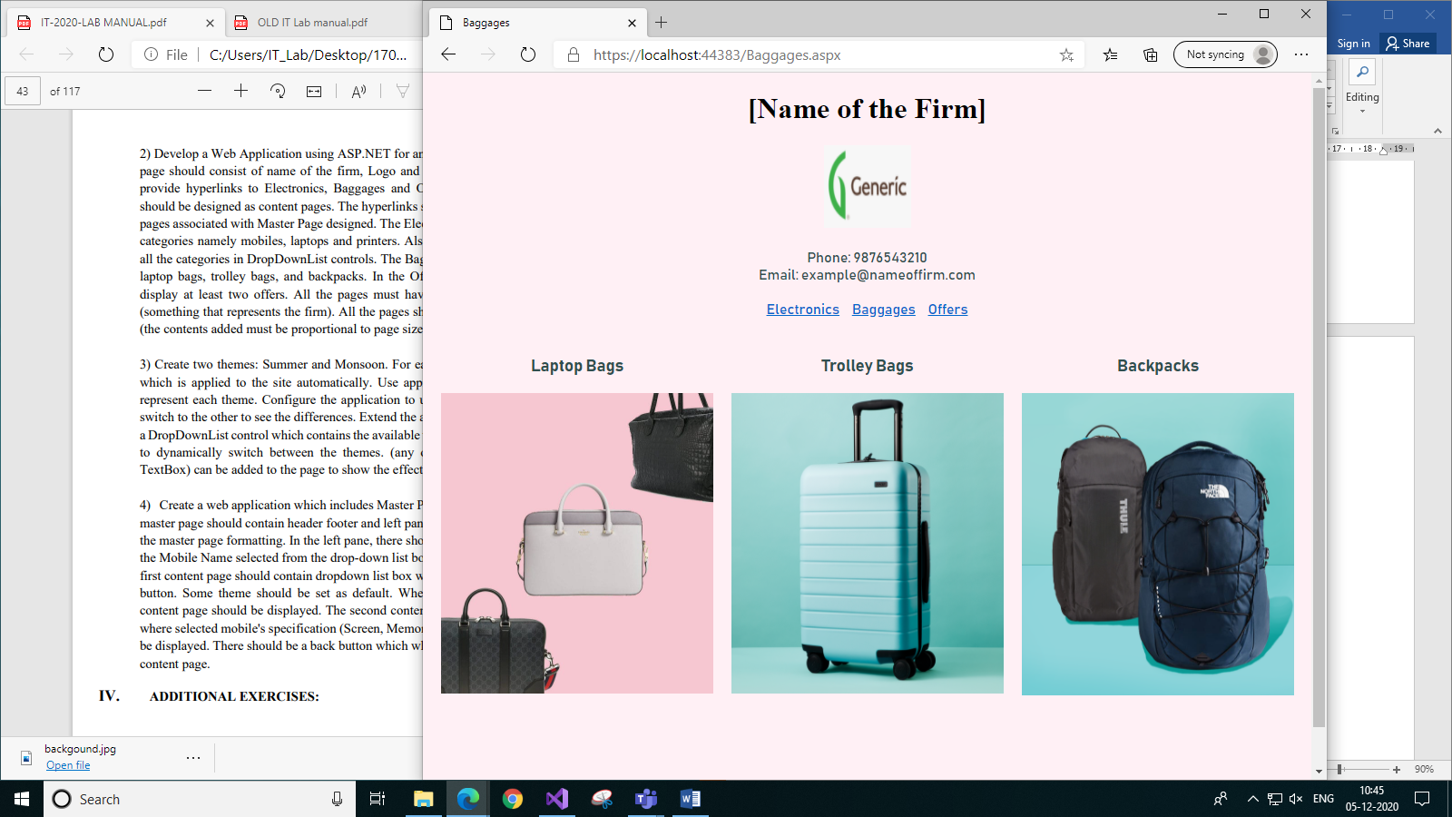

1. *Baggages Page*

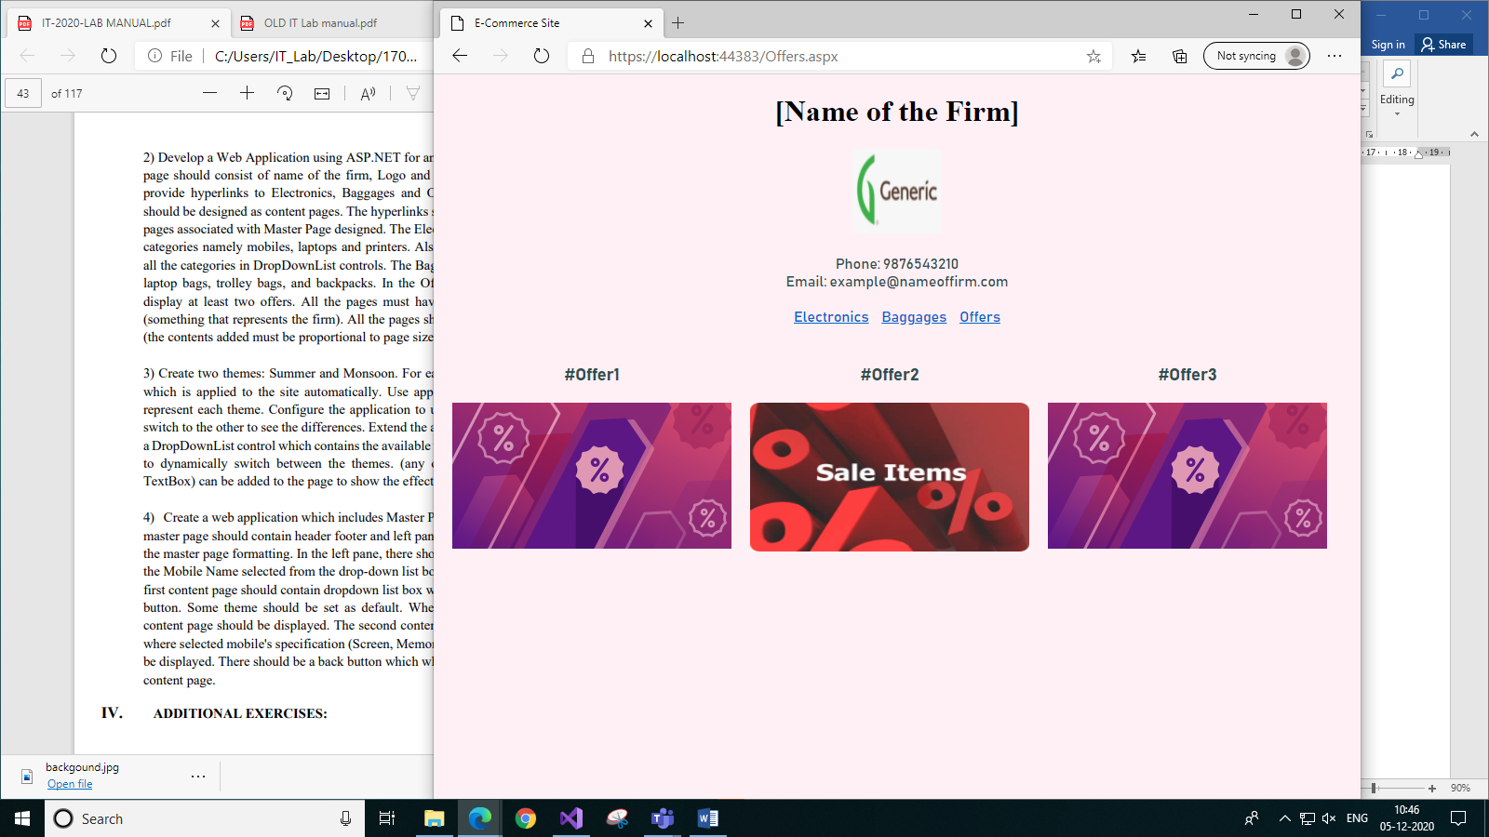

1. *Offers Page*
2. **Create two themes: Summer and Monsoon. For each theme, add the CSS layout, which is applied to the site automatically. Use appropriate background images to represent each theme. Configure the application to use one of the themes and then switch to the other to see the differences. Extend the above-created themes by adding a DropDownList control which contains the available themes so that a user can choose to dynamically switch between the themes. (any other appropriate controls(e.g., TextBox) can be added to the page to show the effect of themes changing).**

**Code:**

**WebForm1.aspx:**

<%@ Page Language="C#" AutoEventWireup="true" CodeBehind="WebForm1.aspx.cs" Inherits="q3.WebForm1"%>

<!DOCTYPE html>

<html xmlns="http://www.w3.org/1999/xhtml">

<head runat="server">

<title>Season Themes</title>

</head>

<body id="body1" style="text-align: center" runat="server">

<form id="form1" runat="server">

<div>

<asp:Label ID="Label1" runat="server" Text="Select the Theme"></asp:Label>

<asp:DropDownList ID="DropDownList1" runat="server" OnSelectedIndexChanged="ChangeTheme" AutoPostBack="true" >

<asp:ListItem></asp:ListItem>

<asp:ListItem>Monsoon</asp:ListItem>

<asp:ListItem>Summer</asp:ListItem>

</asp:DropDownList>

<br />

<br />

<asp:Label ID="Label2" runat="server" Text=""></asp:Label>

</div>

</form>

</body>

</html>

**WebForm1.aspx.cs:**

using System;

using System.Collections.Generic;

using System.Linq;

using System.Web;

using System.Web.UI;

using System.Web.UI.WebControls;

using System.Web.UI.HtmlControls;

namespace q3

{

public partial class WebForm1 : System.Web.UI.Page

{

protected void Page_Load(object sender, EventArgs e)

{

if (!this.IsPostBack)

{

if (Session["Theme"] != null)

{

DropDownList1.Items.FindByText(Session["Theme"].ToString()).Selected = true;

}

}

}

protected void Page_PreInit(object sender, EventArgs e)

{

if (Session["Theme"] != null)

{

Page.Theme = Session["Theme"].ToString();

Label2.Text = Session["Text"].ToString();

}

}

protected void ChangeTheme(object sender, EventArgs e)

{

string res;

var link = new HtmlLink();

if(DropDownList1.SelectedItem.Text == "Monsoon")

{

res = "Monsoon Theme";

Label2.Text = "Monsoon Theme";

link = new HtmlLink();

link.Href = "~/App_Themes/Monsoon/Monsoon.css";

link.Attributes.Add("rel", "stylesheet");

link.Attributes.Add("type", "text/css");

Page.Header.Controls.Add(link);

}

else

{

res = "Summer Theme";

Label2.Text = "Summer Theme";

link = new HtmlLink();

link.Href = "~/App_Themes/Summer/Summer.css";

link.Attributes.Add("rel", "stylesheet");

link.Attributes.Add("type", "text/css");

Page.Header.Controls.Add(link);

}

Session["Theme"] = DropDownList1.SelectedValue;

Session["Text"] = res;

Response.Redirect(Request.FilePath);

}

}

}

**Monsoon Theme:**

**Monsoon.skin:**

<asp:Image runat="server" ImageUrl="~/App_Themes/Monsoon/monsoon.jpg" ImageAlign="Middle" Height="100%" Width="100%" />

<asp:DropDownList runat="server" Font-Bold="true" Font-Names="Comic Sans MS" Height="20px" Width="200px"/>

<asp:Label runat="server" Font-Bold="true" Font-Names="Times New Roman" Font-Size="Large" ForeColor="White" />

**Monsoon.css:**

body {

text-align: center;

background-image: url('/App_Themes/Monsoon/monsoon.jpg');

}

**Summer Theme:**

**Summer.skin:**

<asp:Image runat="server" ImageUrl="~/App_Themes/Summer/summer.jpg" ImageAlign="Middle" Height="100%" Width="100%" />

<asp:DropDownList runat="server" Font-Bold="true" Font-Names="Arial" Height="20px" Width="200px"/>

<asp:Label runat="server" Font-Bold="true" Font-Names="Comic Sans MS" Font-Size="Large"/>

**Summer.css:**

body {

text-align: center;

background-image: url('/App_Themes/Summer/summer.jpg');

}

**Output:**

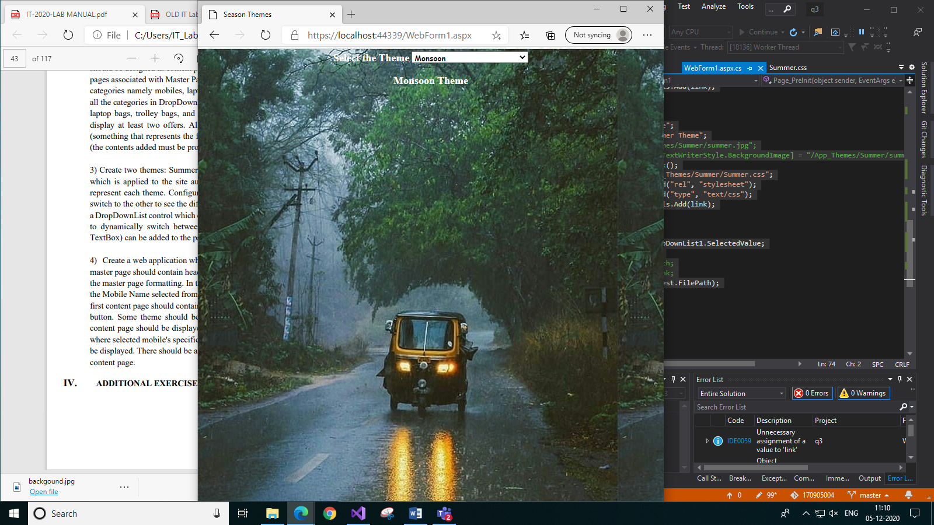

1. *Monsoon Theme*

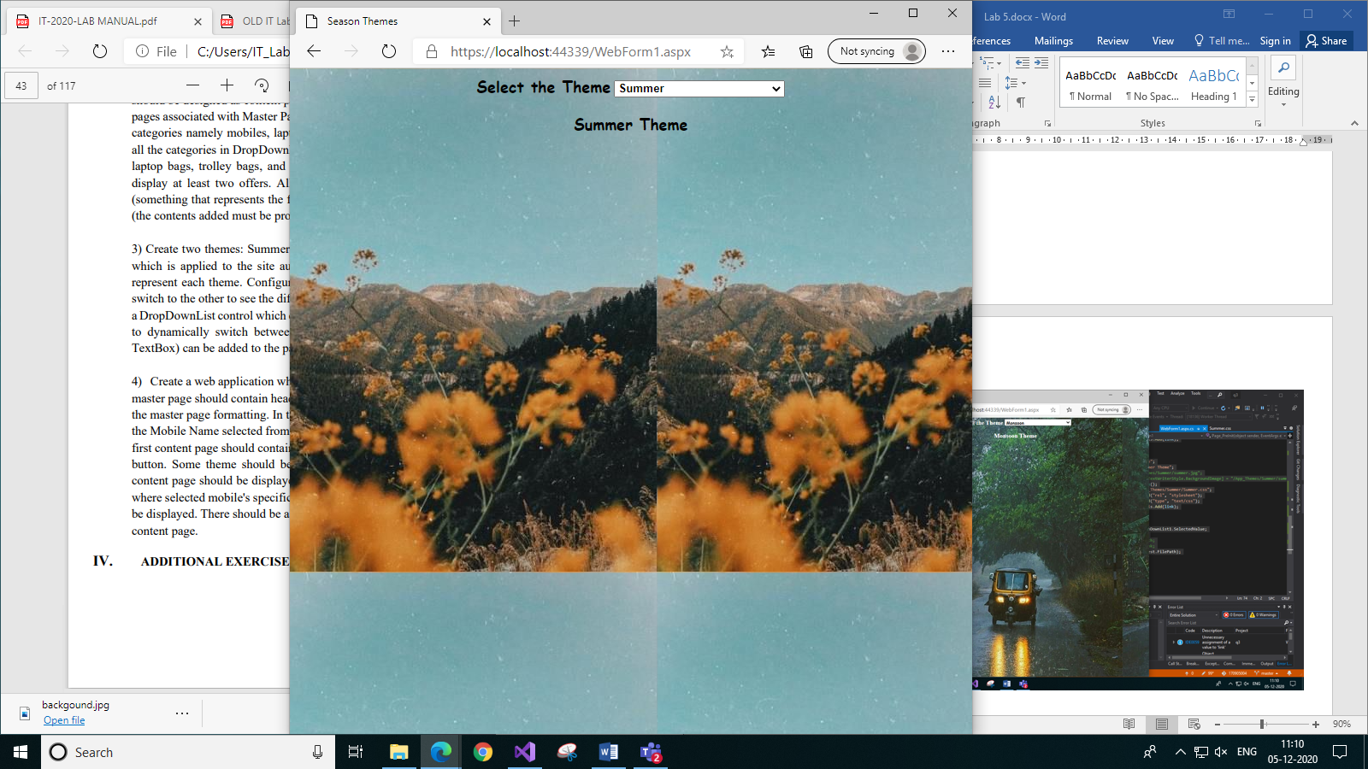

1. *Summer Theme*
2. **Create a web application which includes Master Page and two content pages. The master page should contain header footer and left pane. Include the stylesheet file for the master page formatting. In the left pane, there should be a label. It should display the Mobile Name selected from the drop-down list box of the First content page. The first content page should contain dropdown list box with different mobile names, and button. Some theme should be set as default. When you click the button second content page should be displayed. The second content page should contain the label where selected mobile's specification (Screen, Memory, Camera, and Battery) should be displayed. There should be a back button which when clicked will display the first content page.**

**Code:**

**Site.Master:**

<%@ Master Language="C#" AutoEventWireup="true" CodeBehind="Site1.master.cs" Inherits="q4.Site1" %>

<!DOCTYPE html>

<html>

<head runat="server">

<title>Master Page</title>

<link rel="stylesheet" href="StyleSheet1.css" />

</head>

<body>

<form id="form1" runat="server">

<div class="header">

<br />

<br />

HEADER

</div>

<div class="left-panel">

<asp:Label ID="Label1" runat="server" Text=""></asp:Label>

</div>

<div class="centre-panel">

<asp:ContentPlaceHolder ID="ContentPlaceHolder1" runat="server"></asp:ContentPlaceHolder>

</div>

<div class="footer">

<br />

<br />

FOOTER

</div>

</form>

</body>

</html>

**Site.Master.cs:**

using System;

using System.Collections.Generic;

using System.Linq;

using System.Web;

using System.Web.UI;

using System.Web.UI.WebControls;

namespace q4

{

public partial class Site1 : System.Web.UI.MasterPage

{

protected void Page_Load(object sender, EventArgs e)

{

if(Session["Label"] != null)

{

Label1.Text = Session["Label"].ToString();

}

}

public void ChangeLabel(string val)

{

Label1.Text = val;

}

}

}

**WebForm1.aspx:**

<%@ Page Title="ContentPage1" Language="C#" MasterPageFile="~/Site1.Master" AutoEventWireup="true" CodeBehind="WebForm1.aspx.cs" Inherits="q4.WebForm1" StylesheetTheme="Default"%>

<asp:Content ID="Content1" ContentPlaceHolderID="ContentPlaceHolder1" runat="server">

<asp:DropDownList ID="DropDownList1" runat="server" AutoPostBack="True" OnSelectedIndexChanged="IndexChanged">

</asp:DropDownList>

<br /><br />

<asp:Button ID="Button1" runat="server" Text="Go to next page" OnClick="Button1_Click" />

</asp:Content>

**WebForm1.aspx.cs:**

using System;

using System.Collections.Generic;

using System.Linq;

using System.Web;

using System.Web.UI;

using System.Web.UI.WebControls;

namespace q4

{

public partial class WebForm1 : System.Web.UI.Page

{

protected void Page_Load(object sender, EventArgs e)

{

if (!this.IsPostBack)

{

DropDownList1.Items.Add(new ListItem("Samsung M20", "Screen: 6.30-inch (1080x2340) | Memory: 3+32GB | Camera: 8MP, 13+5MP | Battery: 5000mAh"));

DropDownList1.Items.Add(new ListItem("iPhone X", "Screen: 5.80-inch (1125x2436) | Memory: 3+64GB | Camera: 7MP, 12+12MP | Battery: 2716mAh"));

DropDownList1.Items.Add(new ListItem("OnePlus 7T", "Screen: 6.55-inch (1080x2400)) | Memory: 8+128GB | Camera: 16MP, 48+16+12MP | Battery: 3800mAh"));

}

}

protected void Button1_Click(object sender, EventArgs e)

{

Response.Redirect("WebForm2.aspx");

}

protected void IndexChanged(object sender, EventArgs e)

{

Session["Selected"] = DropDownList1.SelectedItem.Value;

Site1 master = (Site1)this.Master;

string res = "Selected Item is: " + "<br/>" + DropDownList1.SelectedItem.Text;

Session["Label"] = res;

Session["index"] = DropDownList1.SelectedIndex;

master.ChangeLabel(res);

}

}

}

**WebForm2.aspx:**

<%@ Page Title="" Language="C#" MasterPageFile="~/Site1.Master" AutoEventWireup="true" CodeBehind="WebForm2.aspx.cs" Inherits="q4.WebForm2" %>

<asp:Content ID="Content1" ContentPlaceHolderID="ContentPlaceHolder1" runat="server">

<asp:Label ID="Label1" runat="server" Text=""></asp:Label>

<br /><br />

<asp:Button ID="Button1" runat="server" Text="Back to 1st page" OnClick="Button1_Click" />

</asp:Content>

**WebForm2.aspx.cs:**

using System;

using System.Collections.Generic;

using System.Linq;

using System.Web;

using System.Web.UI;

using System.Web.UI.WebControls;

namespace q4

{

public partial class WebForm2 : System.Web.UI.Page

{

protected void Page_Load(object sender, EventArgs e)

{

if(Session["Selected"] != null)

{

string temp = Session["Selected"].ToString();

Label1.Text = "Specifications: " + "<br/>" + temp;

}

}

protected void Button1_Click(object sender, EventArgs e)

{

Response.Redirect("WebForm1.aspx");

}

}

}

**StyleSheet1.css:**

.header {

top: 10px;

height: 100px;

left: 10px;

right: 10px;

position: fixed;

text-align: center;

background-color: gray;

}

.footer {

bottom: 10px;

height: 100px;

left: 10px;

right: 10px;

position: fixed;

text-align: center;

background-color: lightslategray;

top: 439px;

}

.left-panel{

left: 10px;

width: 300px;

position: fixed;

top: 120px;

text-align: center;

background-color: lightsteelblue;

}

.centre-panel{

position: fixed;

top: 120px;

text-align: center;

margin-left: 320px;

}

body {

background-color: mintcream;

}

**Skin1.skin:**

<asp:DropDownList runat="server" Height="30px" Width="111px"/>

<asp:Button runat="server" BackColor="LightGray" ForeColor="Black" Height="30px"/>

**Output:**

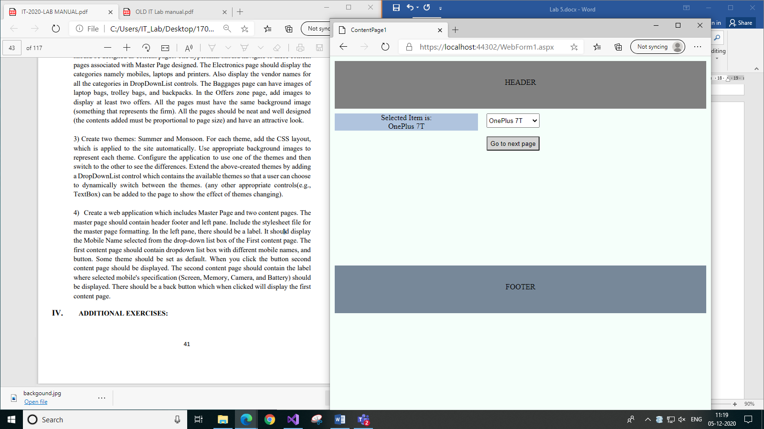

1. *First Page*

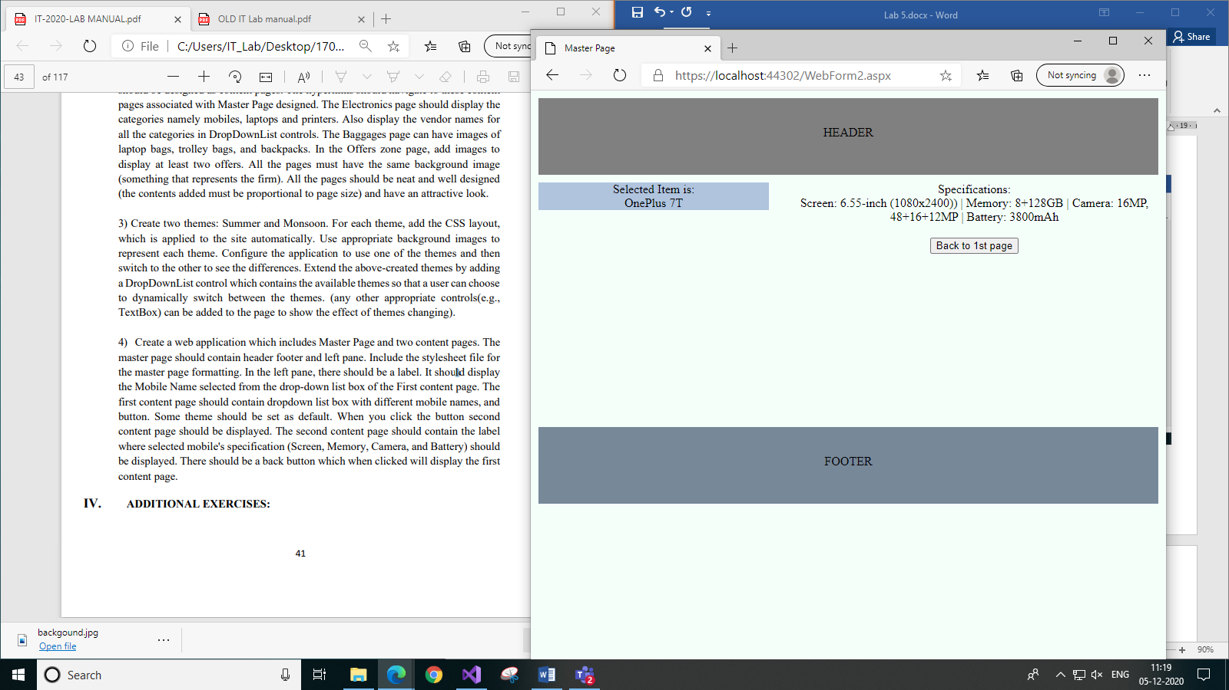

1. *Second Page*